- DDU PROFILE


Dharmsinh DesaiUniversity

ISO 9001:2008

Nadiad - 387 001, Gujarat, India.

University (formerly known as DDIT), was established in June 1968 by Late Shri
Dharmsinh Desai (then Member of Parliament), with a view to provide quality education
in Engineering and Technology to the youth of Gujarat and was affiliated to Gujarat
University.

Having modesty started with Diploma and Degree courses in Chemical Engineering. It has
by now grown as top most Institute of Gujarat offering Graduate and Post Graduate level
courses in various disciplines, and ultimately has become a State University in the year
2005. The institute gained an autonomous status in 1999 with approval from UGC and
Gujarat Government and become a Deemed University accredited by N.B.A. in the year
2000.This University offers Graduate and Post Graduate level coursesin various disciplines
and Master of Computer Applications (MCA) is being run under Faculty of Management
and Information Science since 1987.

The University has also received ISO-9001:2008 Certification from ISOQAR and have also
acquired NAAC accreditation. D.D.University believes not only in providing quality
education, but also provides an overall development of its students in the form of being
disciplined, sociality accountable to the society and responsible citizen of our county.

D.D. University is being guided by the vision laid down by its founding Chairman Late Shri
Dharmsinh Desai, the present Chairman Dr. Narendra Desai and under a strong and
dynamic leadership of Vice-chancellor Dr. H.M.Desai.

Vision:
“Become a multi-disciplined & „learner oriented‟ university to closely associate with and
be responsive to the industry, to create supportive and caring environment for staff and
students and to engage in R & D activities in areas of national priority.”

Mission:
“Undertake programs and projects for development of human resources, both through
formal and non-formal delivery systems, in areas of professional pursuits in all walks of
human endeavors, with accent on relevance, value addition, societal needs and futuristic
pilot projects.”

- COMPANY PROFILE

Company name: Roima Intelligence India private limited
Company address: Satyamev Elite, 608 - 615, Sardar Patel Ring Rd, South Bopal, Bopal, Ahmedabad, Gujarat 380058
Company Email: neha.vindhani@roimaint.com
Company Number: +91 7069692727

About us: Roima Intelligence is a global business-solutions provider specializing in digital transformation for manufacturing, supply chain, logistics, and product lifecycle management.The company delivers a broad portfolio of software and services including ERP, MES/MOM, WMS, PLM, logistics platforms, machine vision, and more to help organizations streamline operations, integrate systems, and manage supply chains effectively.With more than 500 customers worldwide and over 400 professionals working across several countries, Roima brings deep industry expertise and a track record of successful implementations.Roima aims to be a reliable, long-term partner not just a vendor helping clients modernize their infrastructure, improve quality, and operate with greater efficiency and resilience.
Mission: Roima’s mission is to deliver powerful, integrated software that helps businesses improve productivity, quality, and efficiency. They focus on creating measurable, long-lasting results through supply-chain, manufacturing, and logistics solutions. Roima works as a long-term partner, guiding clients through digital transformation and ensuring their systems run smoothly, sustainably, and profitably.
Vision: Roima’s vision is to lead global digital transformation by helping businesses build smart factories and intelligent supply chains. They aim to make operations fully connected, automated, and data-driven so companies can work faster, smarter, and more efficiently. Roima wants to expand internationally and continue innovating solutions that strengthen competitiveness and prepare organizations for the future.

- PROJECT PROFILE

Project Title | HR Management System
Company Name | Roima Intelligence India private limited
Tools | Postman,  Visual Studio,  Vs Code,  SQL Server Management Studio
Duration | 19th January, 2026 to 21th March, 2026
Team Size | 1
Team Member | Kartik Miteshbhai Patel
Internal Guide | Associate Professor Minal V. Shah
External Guide | Yash Shah

- TOOLS & TECHNOLOGY

Tools :-
Sr. No | Tools | Purpose
1 | Visual Studio | Writing Code - Backend
2 | Visual Studio Code | Writing Code – Frontend
3 | SQL Server Manager Studio | Database
4 | Postman | API Testing

Technology :-

Sr. No | Technology | Purpose
1 | Asp.net – C# | Backend Technology
2 | React.js – TypeScript | Frontend Technology
3 | SQL Server Manager Studio | Database

- PROJECT PLANNING

5.1 Project Definition :
The HR Management System (HRMS) is an online platform designed to simplify and automate various human resource operations within an organization. It provides a centralized system where employees, managers, and HR administrators can manage travel plans, expenses, employee engagement activities, game bookings, and recruitment processes efficiently. The system eliminates manual paperwork and scattered communication by offering a structured digital solution for managing HR-related activities.
The system allows HR/Admin to create and assign travel plans to employees, verify and approve submitted expenses, manage employee records, configure game slots, and manage job postings and referrals. Employees can view assigned travel plans, submit expense claims with supporting documents, participate in engagement activities, book game slots, and refer candidates for job openings. Managers can monitor team activities and organizational hierarchy.
By integrating all HR operations into a single platform, the system improves transparency, reduces processing time, and enhances collaboration between employees, managers, and HR teams. The HRMS also provides real-time status tracking, automated notifications, secure document management, and role-based access control to ensure efficient and secure operations.
Example:
Let’s assume that an employee needs to travel for an official meeting. First, the HR/Admin assigns a travel plan through the system. The employee can view the assigned travel details and upload expense receipts after completing the trip. The employee then submits the expense request along with supporting documents.
The HR/Admin reviews the submitted expenses and either approves or rejects them with remarks. At the same time, employees can also participate in engagement activities such as posting achievements, liking posts, or booking game slots. Additionally, employees can view job openings and refer candidates through the system.
After approval, the employee can track the expense status in real time, ensuring transparency and smooth communication between employees and HR.

5.2 Preliminary Investigation :
- Traditional HR processes involve manual paperwork and delayed approvals which reduce efficiency.
- Employees often lack a centralized platform to manage travel plans, expenses, engagement activities, and referrals.
- HR teams face difficulty in managing employee data, approvals, and records through scattered systems.
- There is a need for a centralized digital platform to streamline HR operations and improve transparency.
- Automated notifications help users stay informed about travel assignments, expense approvals, and job referrals.
- Role-based access control ensures secure management of employee information and organizational data.
- SYSTEM ANALYSIS

6.1 Feasibility Study :
6.1.1 Technical Feasibility :

- The proposed HR Management System (HRMS) is technically feasible using a modern Microsoft-based technology stack such as ASP.NET Core Web API, React.js with TypeScript, and SQL Server.
- The backend will be developed using ASP.NET Core Web API, which provides high performance, RESTful API support, dependency injection, and strong security features.
- The frontend will be implemented using React.js with TypeScript, providing a scalable, strongly typed, and maintainable user interface.
- JWT-based authentication and role-based authorization will be used to secure the system and control access for Employees, Managers, and HR administrators.
- Entity Framework Core with SQL Server will be used for ORM-based database access, ensuring data consistency for modules such as travel plans, expenses, achievements, game slots, and job referrals.
- The system supports file upload and document management for receipts, travel documents, CV uploads, and policy files using multipart APIs with validation.
- Email notification services will notify employees and HR regarding travel assignments, expense submissions, referral updates, and system activities.
- Business rules such as expense submission windows, mandatory proof documents, and fair game slot allocation will be implemented in the service layer.
- The backend will support queue-based scheduling logic for fair allocation of game slots among employees.
- Audit logging and status tracking will maintain records of approvals, expense submissions, and referral activities for transparency and compliance.6.1.2 Operational Feasibility :
- The system provides an easy-to-use interface for HR/Admin, Managers, and Employees, enabling efficient HR operations.
- HR/Admin users can create and manage travel plans, verify and approve expenses, configure game slots, manage job openings, and monitor referrals.
- Employees can view travel plans, submit expenses with proof documents, participate in achievements and celebrations, request game slots, and refer candidates for job openings.
- Managers can view team members, monitor achievements, and access travel and expense information of their direct reports.
- The system provides automated notifications through email and in-app alerts for travel assignments, expense approvals, referrals, and system updates.
- Automated validation and business rules reduce manual errors and ensure efficient workflow management.

6.1.3 Economical Feasibility :
- The proposed HRMS system is economically feasible as it uses open-source or freely available technologies such as ASP.NET Core, React with TypeScript, and SQL Server Express/Developer edition.
- The system reduces operational costs by automating HR processes such as travel management, expense tracking, approvals, referrals, and game slot scheduling.
- Centralized data management improves efficiency and reduces administrative workload for HR teams.
- The modular architecture ensures low maintenance costs and easier system updates.
- The system can be deployed on low-cost cloud or on-premise environments, minimizing infrastructure expenses.
- The platform supports future scalability without significant additional cost, allowing organizations to add new features or users easily.

6.2 System Requirement Specification :
6.2.1 Introduction :
The Human Resource Management System (HRMS) is an internal enterprise web-based application designed to automate and manage core HR operations such as travel management, expense reimbursement, employee engagement, games scheduling, organizational hierarchy visualization, and job referral workflows.
The system aims to reduce manual HR processes, improve transparency, and enhance employee engagement by providing a centralized digital platform accessible to Employees, Managers, and HR personnel.
- User & Role Management Module
- Travel & Expense Management Module
- Social Achievements & Celebrations Module
- Games Scheduling Module
- Organization Chart Module
- Job Listing, Sharing & Referral Module
6.2.2 Purpose :
The primary purpose of the HRMS is to provide a secure, centralized, and efficient platform for managing internal HR operations.
The system aims to:
• Automate travel assignments and expense reimbursements
• Reduce manual document handling
• Improve employee engagement through social features
• Ensure fair allocation of shared organizational resources (games)
• Provide transparency in organizational hierarchy
• Simplify job sharing and referral processes
The system helps HR teams:
• Manage employee travel plans and documents
• Track and verify expenses
• Configure job postings and referral workflows
• View organization structure across departments
The system enables employees to:
• View assigned travels and submit expenses
• Upload and manage travel-related documents
• Participate in internal social activities
• Book game slots fairly
• Refer friends for job openings

6.2.3 Problem Statement :
Organizations relying on manual or partially automated HR processes face challenges such as:
- Delays in travel communication and expense reimbursement
- Poor visibility of organizational hierarchy
- Unfair usage of shared recreational resources
- Inefficient job referral tracking
- Lack of employee engagement platforms
The HRMS solves these problems by digitizing and automating HR workflows with role-based access control and centralized data management.
6.2.4 Scope :
6.2.4.1 User Management Module
• Registration/Login : Employees, Managers, and HR users can securely log in to the system using authentication credentials.
• Profile Management : Users can view and manage their personal profile information within the system.
• Role-Based Access : The system supports different roles such as Employee, Manager, and HR, and each role can access features according to their permissions.
6.2.4.2 Travel Management Module
• Travel Creation and Assignment : HR can create travel plans and assign them to one or more employees.
• View Travel Details :
Employees can view their assigned travel plans and related information.
6.2.4.3 Expense Management Module
• Expense Submission : Employees can submit expenses related to their assigned travel with proof documents.
• Expense Verification : HR can verify, approve, or reject submitted expenses and update their status.
6.2.4.4 Achievements & Engagement Module
• Social Achievements Feed : Employees can create achievement posts and view posts shared by others.
• Likes and Comments : Users can like and comment on achievement posts and participate in engagement activities.
6.2.4.5 Game Slot Management Module
• Game Slot Scheduling : HR can configure game slots, including timing, duration, and capacity.
• Fair Slot Allocation : Employees can request game slots, and the system allocates them fairly according to defined rules.
6.2.4.6 Organization Chart Module
• Hierarchy Visualization : Employees can view the organizational hierarchy and managerial chain within the system.
• Employee Relationship View : The system displays reporting relationships between employees and managers.

6.2.4.7 Job Listing & Referral Module
• Job Listing and Sharing : HR can create and manage job openings available in the organization.
• Employee Referrals : Employees can refer candidates for job openings and track referral status.

6.2.5 Audience and Users :
I. Employee: Views travels, submits expenses, posts achievements, books game slots, refers jobs
II. Manager: View team member, travel documents, expense (read-only), organizational chart
III. Hr: Manager travels, expenses, documents, jobs, referrals, and organizational chart
6.2.6 Overview :
6.2.6.1 Hardware and software (for development)
Hardware Requirements
Processor | Intel core i5 or higher
RAM | 8 GB
Software Requirements
Backend | ASP.NET Core
Database | SQL Server
Tools | Visual Studio, Visual Studio code, Postman
Browser | Latest versions of Chrome, Edge, Firefox

6.2.6.2 Hardware and software (for User)
Hardware Requirements
Processor | Intel core i3 or higher
RAM | 4 GB
Software Requirements
Operating System | Windows, Ios, Android
Browser | All Latest Browser

6.2.7 Acronyms and Abbreviations :
• HRMS – Human Resource Management System
• API – Application Programming Interface
• DB – Database
• JWT – JSON Web Token
• RBAC – Role-Based Access Control
6.2.8 Functional Requirements :

      - User & Role Management module :
        - Common Requirements :
          - The system shall authenticate users using secure login credentials.
          - The system shall enforce role-based access control.
          - The system shall store encrypted passwords.
        - Employee :
          - The employee shall be able to view and update profile information.
          - The employee shall report to a manager and belong to a department.
        - Manager :
          - The manager shall be able to view direct reports.
          - The manager shall appear correctly in the organization chart.
        - HR :
          - HR shall be able to view all employees and departments.
          - HR shall manage travel plans, expenses, jobs, and referrals.

      - Travel & Expense Management Module :
        - Travel Assignment :
          - HR shall be able to create travel plans for one or more employees.
          - The system shall notify employees via email and in-app notification.
          - Each travel shall include dates, location, and expense limit.
        - Travel Document :
          - The system shall allow HR and employees to upload documents.
          - Each document shall store:
            - Travel ID
            - Employee ID
            - Uploaded by
            - Document type
            - File URL
            - Uploaded date
          - Permissions:
            - HR: View/upload all documents
            - Employee: View/upload own documents
            - Manager: View team documents (read-only)
        - Expense Submission :
          - Expenses shall always be linked to a travel.
          - Employees may submit expenses only:
            - After travel start date
            - Within 10 days of travel end date
          - The system shall block late submissions.
          - Multiple expenses per travel shall be supported.
        - Proof Upload & Verification :
          - Each expense must include at least one proof document.
          - HR shall be able to approve or reject expenses.
          - Rejection requires mandatory remarks.
          - Status values: Draft, Submitted, Approved, Rejected
      - Social Achievement & Celebrations Module
        - Achievement Posts :
          - Employee Can Create Achievement posts with:
            - Title
            - Description
            - Tags
            - Visibility
          - All User can view posts in reverse chronological order
          - Users can like and comment on posts.
        - Moderation :
          - Employee can edit/delete their posts
          - HR can delete inappropriate posts.
          - System shall send a warning email on HR moderation
        - Birthday & Anniversary :
          - The system shall auto-generate system posts for:
            - Employee Birthday
            - Work Anniversaries
          - Auto-generate system posts shall be visible to all users
      - Game Scheduling Module :
        - Configuration :
          - HR/Admin can configure:
            - Operating Hours
            - Slot Durations
            - Max and Min Players per slot
          - System shall generate daily slot automatically
        - Booking Rules :
          - Employee can request slots for game
          - One active booking per employee per day
          - Fair scheduling shall be enforced.
          - Cancellation shall assign next eligible player.
      - Organization Chart Module :
          - The system shall display the managerial chain of an employee
          - The system shall show one level of direct reports
          - Each node shall display:
            - Name
            - Designation
            - Profile image
          - Clicking a node reloads the organization chart for that employee
      - Job Listing, Sharing & Referral Module :
        - Job Listing :
          - The system shall list active job openings
          - Employee can browse job details
        - Job Sharing :
          - Employee can share job via email
          - The system shall attach the job description document
          - Sharing activity shall be logged
        - Job Referrals :
          - Employee can refer friends with:
            - Name
            - Email
            - CV
            - Note
          - The system shall email:
            - HR owner
            - Configured reviewers
          - Referral status shall be tracked
    - Non-Functional Requirements :
      - Accessibility
          - The system shall be accessible via modern web browsers.
          - UI shall be responsive across devices.
      - Availability
          - The system shall be available 24×7 except maintenance.
          - Concurrent users shall be supported.
      - Performance
          - Frequently accessed data shall be optimized.
          - API responses shall be efficient.
      - Security
          - JWT-based authentication shall be enforced.
          - Role-based authorization shall be applied.
          - File uploads shall be validated.
      - Maintainability
          - Modular architecture shall be followed.
          - Database design shall support future expansion.

    - Other Information :
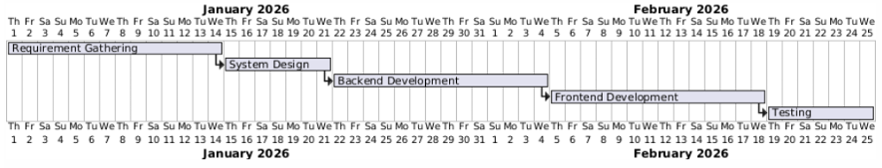
        - Gantt Chart :

- SYSTEM DESIGN
7.1 Architectural Design :
7.1.1 Usecase Diagrams :
7.1.1.1 HR usecase Diagram:
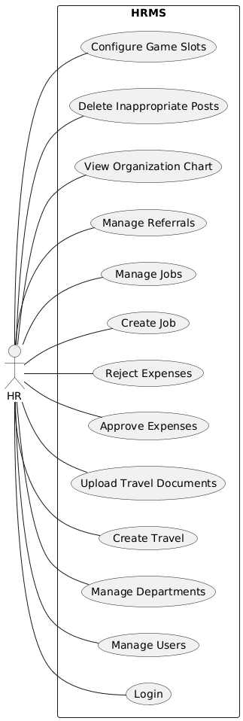
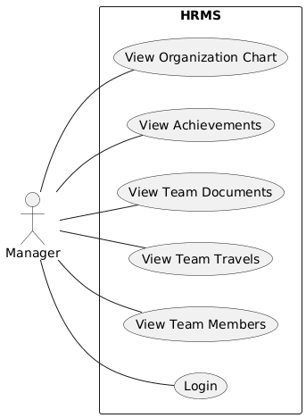
7.1.1.2 Manager usecase Diagram:

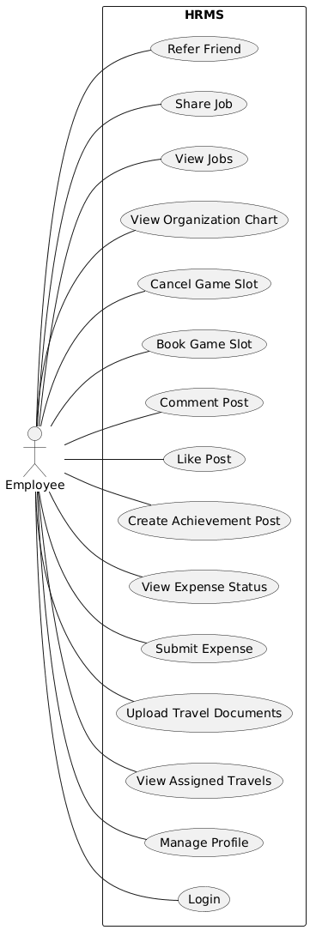
7.1.1.3 Employee usecase Diagram:
    - Activity Diagrams :
      - Create Travel :
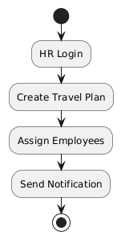
      - Travel Expense :
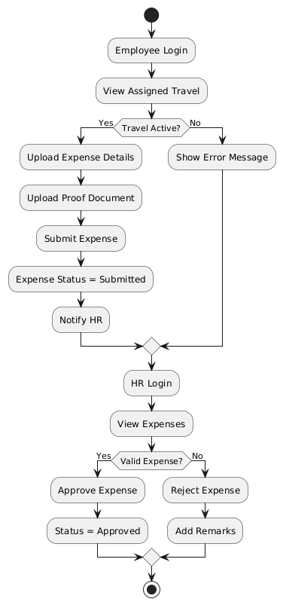
      - Book Game :
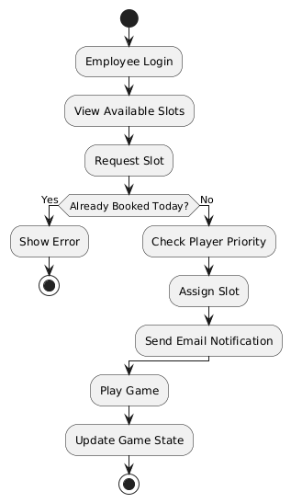
      - Post Create :
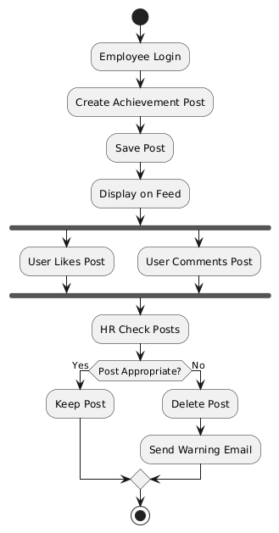
      - Job Referral :
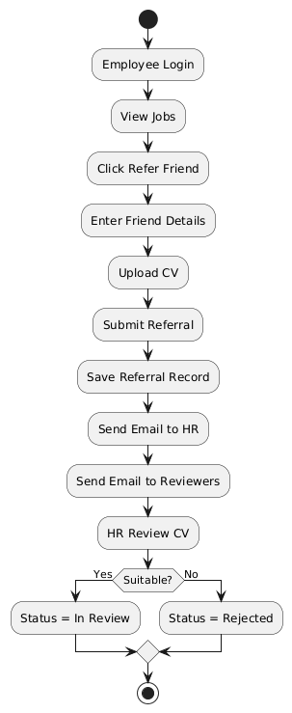
    - Class Diagram :
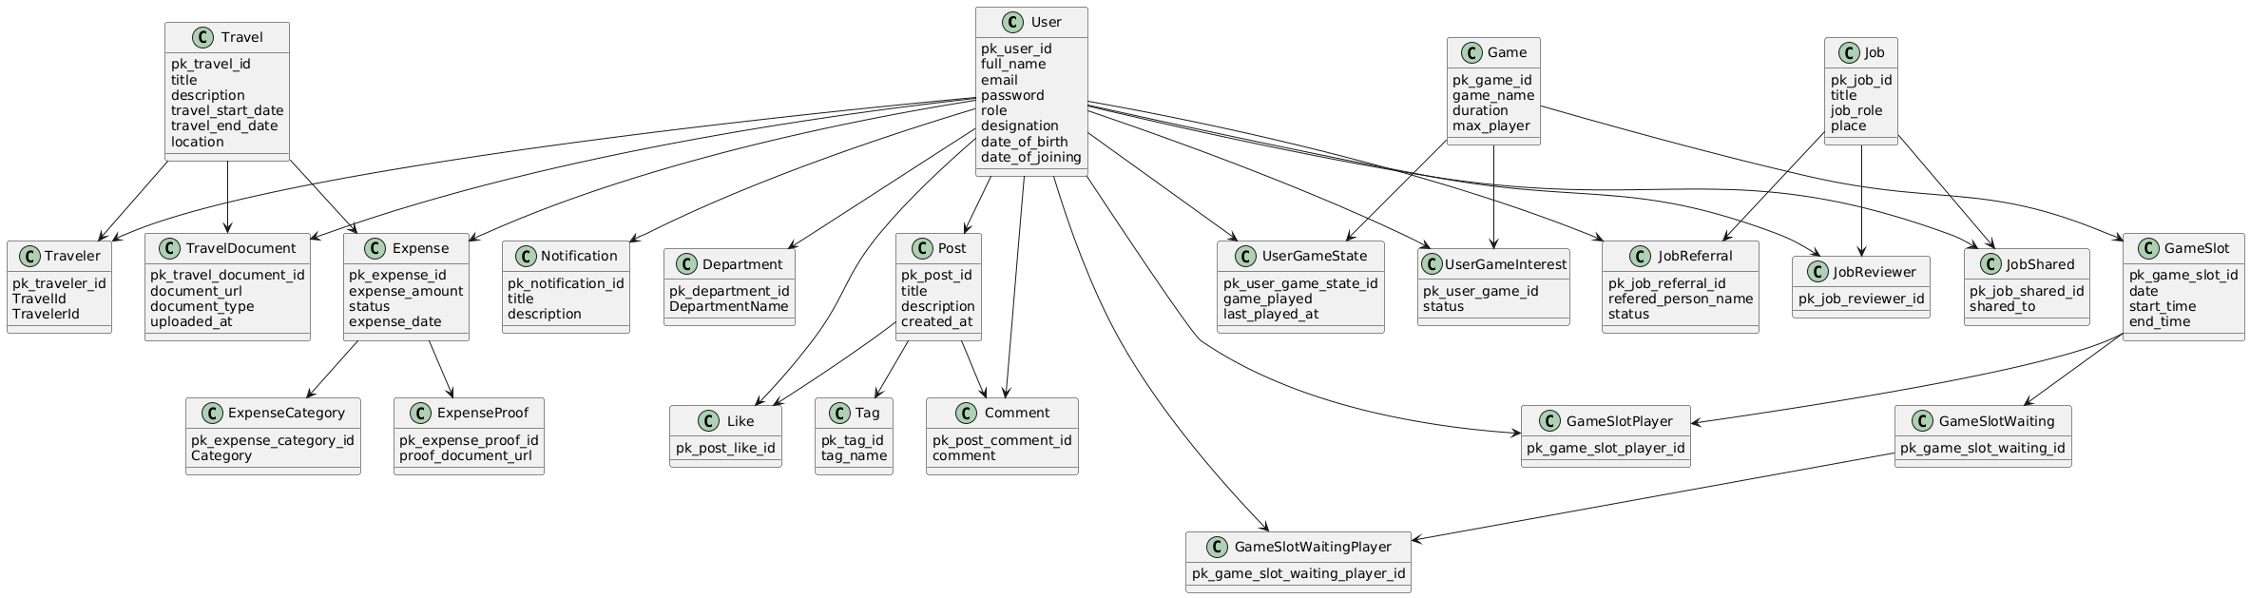
    - Sequence Diagram :
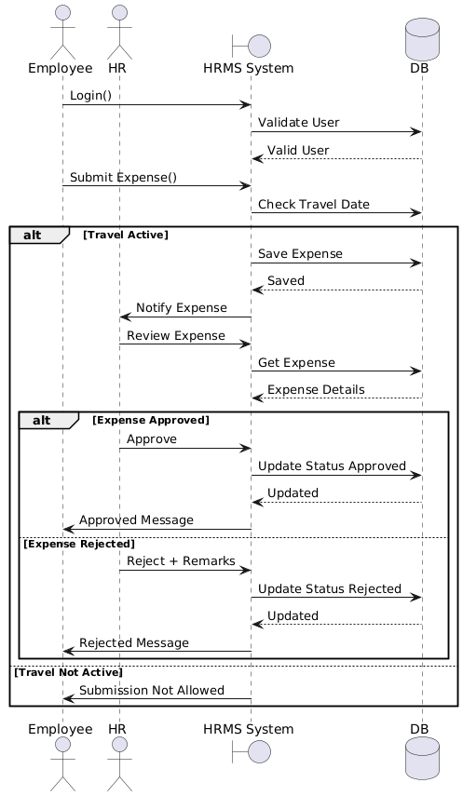
      - Travel Expense Sequence :

      - Job Referral Sequence :
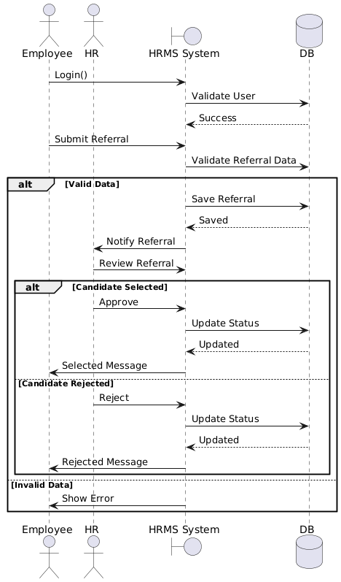
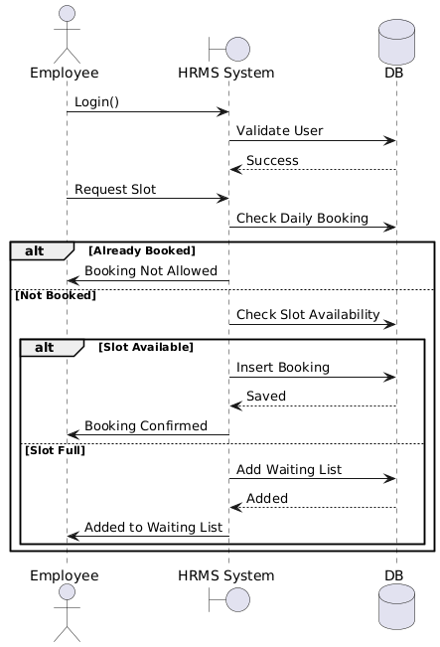
      - Slot Booking Sequence :

  - ER Diagram :
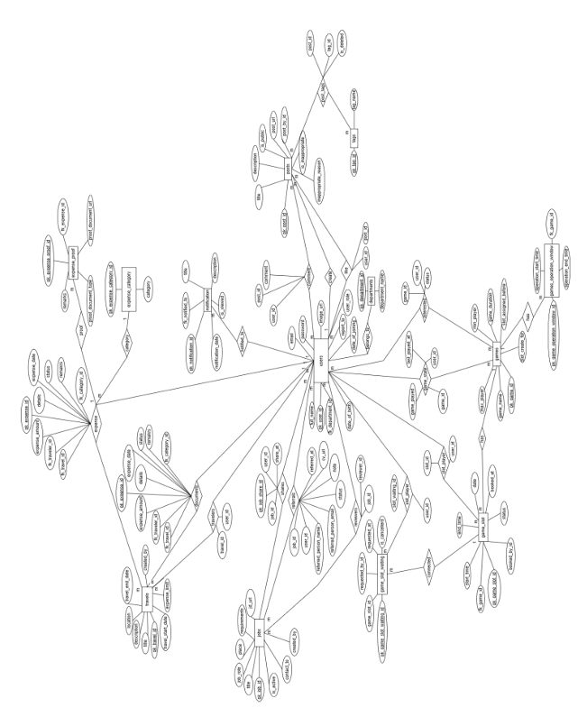
  - Data Dictionary :

    - daily_celebrations : used to store daily celebration related data
Sr.No | Column Name | Data Type | Size | Constraint | Description
1 | pk_daily_celebration_id | INT | - | PK, Identity | Celebration ID
2 | UserId | INT | - | FK(users) | Employee
3 | celebration_type | INT | - | NOT NULL | Birthday / Anniversary
4 | celebration_date | DATETIME2 | - | NOT NULL | Celebration date

    - departments : used to store department of system
Sr.No | Column Name | Data Type | Size | Constraint | Description
1 | pk_department_id | INT | - | PK, Identity | Department ID
2 | DepartmentName | NVARCHAR | 30 | NOT NULL | Department name
3 | is_deleted | BIT | - | NOT NULL | Soft delete
4 | created_at | DATETIME2 | - | DEFAULT | Created time
5 | updated_at | DATETIME2 | - | DEFAULT | Updated time

    - expense_category : used to store expense category
Sr.No | Column Name | Data Type | Size | Constraint | Description
1 | pk_expense_category_id | INT | - | PK, Identity | Category ID
2 | Category | NVARCHAR | 50 | NOT NULL | Expense category
3 | is_deleted | BIT | - | NOT NULL | Soft delete

    - expense_proof : used to store proof(document) related to expense
Sr.No | Column Name | Data Type | Size | Constraint | Description
1 | pk_expense_proof_id | INT | - | PK, Identity | Proof ID
2 | ExpenseId | INT | - | FK(expenses) | Expense reference
3 | proof_document_url | NVARCHAR | 500 | NOT NULL | Document URL
4 | expense_document_type | NVARCHAR | 50 | NOT NULL | Document type
5 | remarks | NVARCHAR | 200 | NOT NULL | Remarks

    - expense : used to store expense related data

Sr.No | Column Name | Data Type | Size | Constraint | Description
1 | pk_expense_id | INT | - | PK, Identity | Expense ID
2 | TravelId | INT | - | FK(travels) | Travel
3 | TravelerId | INT | - | FK(users) | Employee
4 | expense_amount | DECIMAL | 10,2 | NOT NULL | Amount
5 | CategoryId | INT | - | FK(  expense_category) | Category
6 | status | NVARCHAR | 20 | NOT NULL | Draft/Submitted/  Approved/Rejected
7 | remarks | NVARCHAR | 100 | NOT NULL | Remarks
8 | details | NVARCHAR | 200 | NOT NULL | Details
9 | expense_date | DATETIME2 | - | NOT NULL | Expense date
10 | is_deleted | BIT | - | NOT NULL | Soft delete
11 | created_at | DATETIME2 | - | DEFAULT | Created time
12 | updated_at | DATETIME2 | - | DEFAULT | Updated time

    - game_operation_window : used to store operationg hours of game

Sr.No | Column Name | Data Type | Size | Constraint | Description
1 | pk_game_operation_window_id | INT | - | PK, Identity | Window ID
2 | GameId | INT | - | FK(games) | Game
3 | operational_start_time | TIME | - | NOT NULL | Start time
4 | operational_end_time | TIME | - | NOT NULL | End time
5 | is_deleted | BIT | - | NOT NULL | Soft delete
6 | created_at | DATETIME2 | - | NOT NULL | Created time
7 | updated_at | DATETIME2 | - | NOT NULL | Updated time

    - game_slot_players : used to store players of the slot of game

Sr.No | Column Name | Data Type | Size | Constraint | Description
1 | pk_game_slot_player_id | INT | - | PK, Identity | Game slot player ID
2 | SlotId | INT | - | FK(game_slots) | Game slot
3 | PlayerId | INT | - | FK(users) | Player

    - game_slot_waiting : used to store waiting list of the game

Sr.No | Column Name | Data Type | Size | Constraint | Description
1 | pk_game_slot_waiting_id | INT | - | PK, Identity | Waiting ID
2 | GameSlotId | INT | - | FK(game_slots) | Game slot
3 | RequestedById | INT | - | FK(users) | Requested by
4 | requested_at | DATETIME2 | - | DEFAULT | Requested time
5 | is_cancelled | BIT | - | NOT NULL | Cancellation flag

    - game_slot_waiting_players : used to store player listing who are in waiting list of specific game

Sr.No | Column Name | Data Type | Size | Constraint | Description
1 | pk_game_slot_waiting_player_id | INT | - | PK, Identity | Waiting player ID
2 | GameSlotWaitingId | INT | - | FK(game_slot_waiting) | Waiting slot
3 | PlayerId | INT | - | FK(users) | Player

    - game_slot : used to store auto-generated slot of the game.
Sr.No | Column Name | Data Type | Size | Constraint | Description
1 | pk_game_slot_id | INT | - | PK, Identity | Slot ID
2 | GameId | INT | - | FK(games) | Game
3 | start_time | TIME | - | NOT NULL | Start time
4 | end_time | TIME | - | NOT NULL | End time
5 | date | DATETIME2 | - | NOT NULL | Slot date
6 | BookedById | INT | - | FK(users) | Booked by
7 | booked_at | DATETIME2 | - | NULL | Booked time
8 | Status | INT | - | NOT NULL | Slot status

    - games : used to store game of the system

Sr.No | Column Name | Data Type | Size | Constraint | Description
1 | pk_game_id | INT | - | PK, Identity | Game ID
2 | game_name | NVARCHAR | 30 | NOT NULL | Game name
3 | max_player_per_game | INT | - | NOT NULL | Max players
4 | min_player_per_game | INT | - | NOT NULL | Min players
5 | duration_in_minutes | INT | - | NOT NULL | Duration
6 | slot_assigned_before_x_minutes | INT | - | NOT NULL | Buffer time
7 | slot_create_for_next_x_days | INT | - | NOT NULL | Slot generation days
8 | is_deleted | BIT | - | NOT NULL | Soft delete
9 | created_at | DATETIME2 | - | DEFAULT | Created time
10 | updated_at | DATETIME2 | - | DEFAULT | Updated time

    - job_referrals : used to store job referrals on specific job

Sr.No | Column Name | Data Type | Size | Constraint | Description
1 | pk_job_referral_id | INT | - | PK, Identity | Referral ID
2 | refered_person_name | NVARCHAR | 50 | NOT NULL | Candidate name
3 | refered_person_email | NVARCHAR | 50 | NOT NULL | Candidate email
4 | cv_url | NVARCHAR | 500 | NOT NULL | CV URL
5 | note | NVARCHAR | 500 | NOT NULL | Note
6 | status | NVARCHAR | 20 | NOT NULL | Status
7 | ReferedBy | INT | - | FK(users) | Referred by
8 | JobId | INT | - | FK(jobs) | Job
9 | is_deleted | BIT | - | NOT NULL | Soft delete
10 | refered_at | DATETIME2 | - | NOT NULL | Referral date
    - job_reviewers : used to store reviewers of specific job
Sr.No | Column Name | Data Type | Size | Constraint | Description
1 | pk_job_reviewer_id | INT | - | PK, Identity | Job reviewer ID
2 | JobId | INT | - | FK(jobs) | Job
3 | ReviewerId | INT | - | FK(users) | Reviewer

    - job_shared : used to store job share records
Sr.No | Column Name | Data Type | Size | Constraint | Description
1 | pk_job_shared_id | INT | - | PK, Identity | Job share ID
2 | shared_to | NVARCHAR | 50 | NOT NULL | Shared email
3 | shared_at | INT | - | FK(users) | Shared by
4 | JobId | INT | - | FK(jobs) | Job
5 | is_deleted | BIT | - | NOT NULL | Soft delete
6 | SharedAt | DATETIME2 | - | NOT NULL | Shared date

    - jobs : used to store jobs of the system
Sr.No | Column Name | Data Type | Size | Constraint | Description
1 | pk_job_id | INT | - | PK, Identity | Job ID
2 | title | NVARCHAR | 50 | NOT NULL | Job title
3 | job_role | NVARCHAR | 20 | NOT NULL | Role
4 | place | NVARCHAR | 30 | NOT NULL | Location
5 | requirements | NVARCHAR | 300 | NOT NULL | Requirements
6 | jd_url | NVARCHAR | 500 | NOT NULL | JD URL
7 | CreatedBy | INT | - | FK(users) | Created by
8 | ContactTo | INT | - | FK(users) | HR contact
9 | is_active | BIT | - | NOT NULL | Active
10 | is_deleted | BIT | - | NOT NULL | Soft delete
11 | created_at | DATETIME2 | - | DEFAULT | Created time
12 | updated_at | DATETIME2 | - | DEFAULT | Updated time

    - notifications : used to store notification of system
Sr.No | Column Name | Data Type | Size | Constraint | Description
1 | pk_notification_id | INT | - | PK, Identity | Notification ID
2 | NotifiedTo | INT | - | FK(users) | User
3 | title | NVARCHAR | 50 | NOT NULL | Title
4 | description | NVARCHAR | 500 | NOT NULL | Description
5 | is_viewed | BIT | - | NOT NULL | Viewed
6 | notification_date | DATETIME2 | - | NOT NULL | Date

    - post_comments : used to store comment on posts.
Sr.No | Column Name | Data Type | Size | Constraint | Description
1 | pk_post_comment_id | INT | - | PK, Identity | Comment ID
2 | comment | NVARCHAR | 500 | NOT NULL | Comment text
3 | PostId | INT | - | FK(posts) | Post
4 | CommentById | INT | - | FK(users) | Commented by
5 | is_deleted | BIT | - | NOT NULL | Soft delete
6 | created_at | DATETIME2 | - | DEFAULT | Created time
7 | updated_at | DATETIME2 | - | DEFAULT | Updated time

    - post_likes : used to store like on the post
Sr.No | Column Name | Data Type | Size | Constraint | Description
1 | pk_post_like_id | INT | - | PK, Identity | Like ID
2 | PostId | INT | - | FK(posts) | Post
3 | LikedById | INT | - | FK(users) | Liked by
4 | is_deleted | BIT | - | NOT NULL | Soft delete

    - post_tages : used to store tag of the post
Sr.No | Column Name | Data Type | Size | Constraint | Description
1 | pk_post_tag_id | INT | - | PK, Identity | Post tag ID
2 | PostId | INT | - | FK(posts) | Post
3 | TagId | INT | - | FK(tags) | Tag
4 | is_deleted | BIT | - | NOT NULL | Soft delete

    - posts : used to store post created by users
Sr.No | Column Name | Data Type | Size | Constraint | Description
1 | pk_post_id | INT | - | PK, Identity | Post ID
2 | post_url | NVARCHAR | 500 | NOT NULL | Media URL
3 | PostById | INT | - | FK(users) | Posted by
4 | title | NVARCHAR | 100 | NOT NULL | Title
5 | description | NVARCHAR | 1000 | NOT NULL | Description
6 | is_public | BIT | - | NOT NULL | Visibility
7 | is_inappropriate | BIT | - | NOT NULL | Moderation flag
8 | inappropriate_reason | NVARCHAR | 500 | NULL | Reason
9 | is_deleted | BIT | - | NOT NULL | Soft delete
10 | created_at | DATETIME2 | - | DEFAULT | Created
11 | updated_at | DATETIME2 | - | DEFAULT | Updated

    - tags : used to store common tag of system for post
Sr.No | Column Name | Data Type | Size | Constraint | Description
1 | pk_tag_id | INT | - | PK, Identity | Tag ID
2 | tag_name | NVARCHAR | 30 | NOT NULL | Tag name
3 | IsDeleted | BIT | - | NOT NULL | Soft delete

    - travel_documents : used to store document of travel
Sr.No | Column Name | Data Type | Size | Constraint | Description
1 | pk_travel_document_id | INT | - | PK, Identity | Document ID
2 | TravelId | INT | - | FK(travels) | Travel
3 | TravelerId | INT | - | FK(users) | Traveler
4 | document_url | NVARCHAR | 400 | NOT NULL | Document URL
5 | document_name | NVARCHAR | 30 | NOT NULL | Document name
6 | document_type | NVARCHAR | 50 | NOT NULL | Document type
7 | UploadedBy | INT | - | FK(users) | Uploaded by
8 | uploaded_at | DATETIME2 | - | NOT NULL | Upload time
9 | is_deleted | BIT | - | NOT NULL | Soft delete

    - travellers : used to store travellers of specific travel
Sr.No | Column Name | Data Type | Size | Constraint | Description
1 | pk_traveler_id | INT | - | PK, Identity | Traveler ID
2 | TravelId | INT | - | FK(travels) | Travel
3 | TravelerId | INT | - | FK(users) | Traveler
4 | is_deletd | BIT | - | NOT NULL | Soft delete

    - travels : used to store travel data
Sr.No | Column Name | Data Type | Size | Constraint | Description
1 | pk_travel_id | INT | - | PK, Identity | Travel ID
2 | title | NVARCHAR | 50 | NOT NULL | Title
3 | description | NVARCHAR | 300 | NOT NULL | Description
4 | travel_start_date | DATETIME2 | - | NOT NULL | Start date
5 | trael_end_date | DATETIME2 | - | NOT NULL | End date
6 | location | NVARCHAR | 50 | NOT NULL | Location
7 | CreatedBy | INT | - | FK(users) | Created by
8 | expense_max_amount_limit | DECIMAL | 10,2 | NOT NULL | Limit
9 | is_deleted | BIT | - | NOT NULL | Soft delete
10 | created_at | DATETIME2 | - | DEFAULT | Created
11 | updated_at | DATETIME2 | - | DEFAULT | Updated

    - user_game_interest : used to store game interest of user in specific game
Sr.No | Column Name | Data Type | Size | Constraint | Description
1 | pk_user_game_id | INT | - | PK, Identity | Interest ID
2 | GameId | INT | - | FK(games) | Game
3 | UserId | INT | - | FK(users) | User
4 | status | NVARCHAR | 20 | NOT NULL | Interest status

    - user_game_state : used to store state of user on specific game
Sr.No | Column Name | Data Type | Size | Constraint | Description
1 | pk_user_game_state_id | INT | - | PK, Identity | Game state ID
2 | GameId | INT | - | FK(games) | Game
3 | UserId | INT | - | FK(users) | User
4 | game_played | INT | - | NOT NULL | Times played
5 | last_played_at | DATETIME2 | - | NOT NULL | Last played time

    - users : used to store data related to system user
Sr.No | Column Name | Data Type | Size | Constraint | Description
1 | pk_user_id | INT | - | PK, Identity | User ID
2 | full_name | NVARCHAR | 150 | NOT NULL | Full name
3 | email | NVARCHAR | 50 | UNIQUE, NOT NULL | Email
4 | password | NVARCHAR | 500 | NOT NULL | Password
5 | image_url | NVARCHAR | 500 | NOT NULL | Profile image
6 | user_role | NVARCHAR | 15 | NOT NULL | Role
7 | date_of_birth | DATETIME2 | - | NOT NULL | DOB
8 | date_of_joining | DATETIME2 | - | NOT NULL | DOJ
9 | ReportTo | INT | - | FK(users) | Manager
10 | DepartmentId | INT | - | FK(departments) | Department
11 | designation | NVARCHAR | 30 | NOT NULL | Designation
12 | is_deleted | BIT | - | NOT NULL | Soft delete
13 | created_at | DATETIME2 | - | DEFAULT | Created
14 | updated_at | DATETIME2 | - | DEFAULT | Updated

- IMPLEMENTATION OF SYSTEM
8.1 Screen Snapshots :
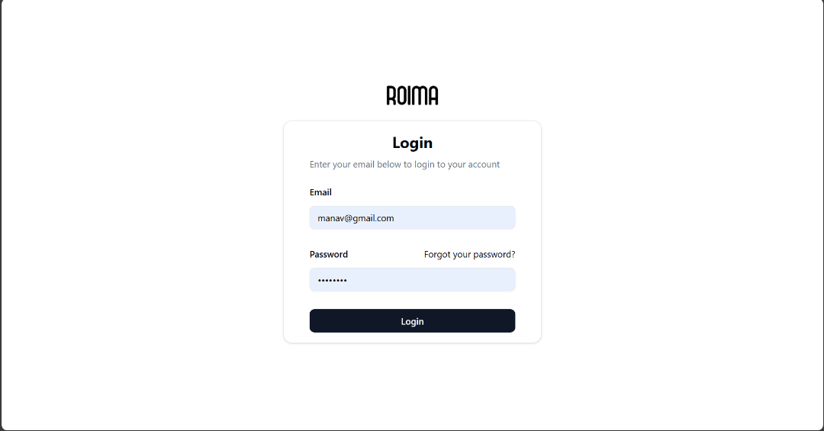

- Login Page Used to login into system
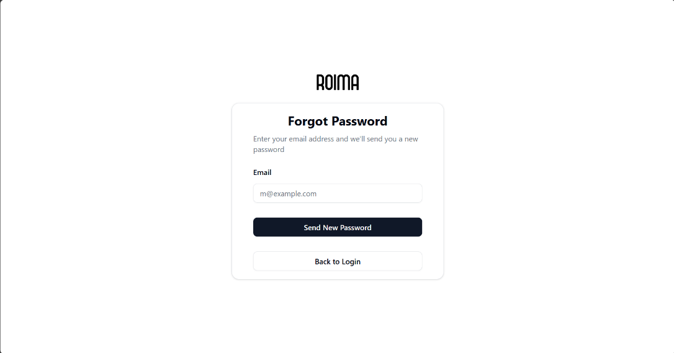

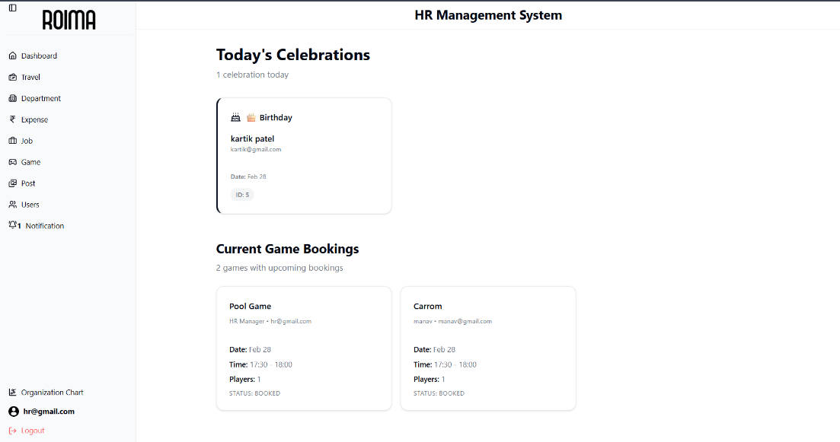
- Forget password to generate new password and get in email

- Dashboard for HR of system
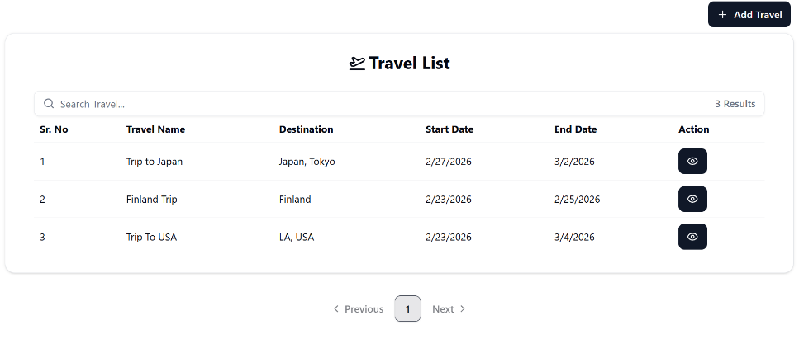
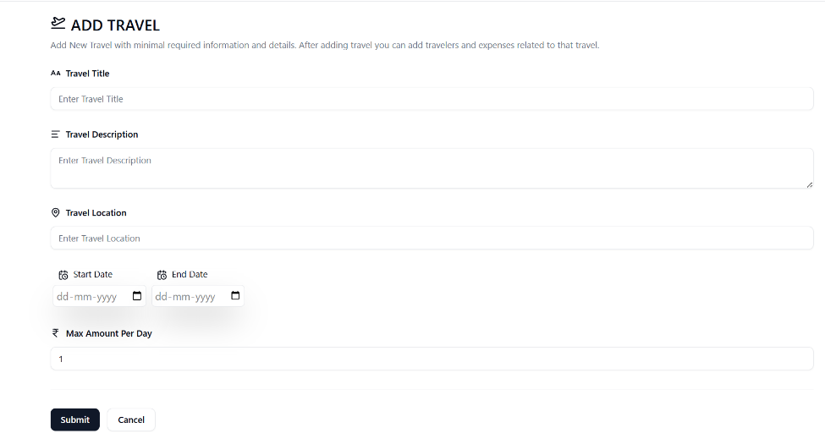
- List All Travel Created by Logged in HR
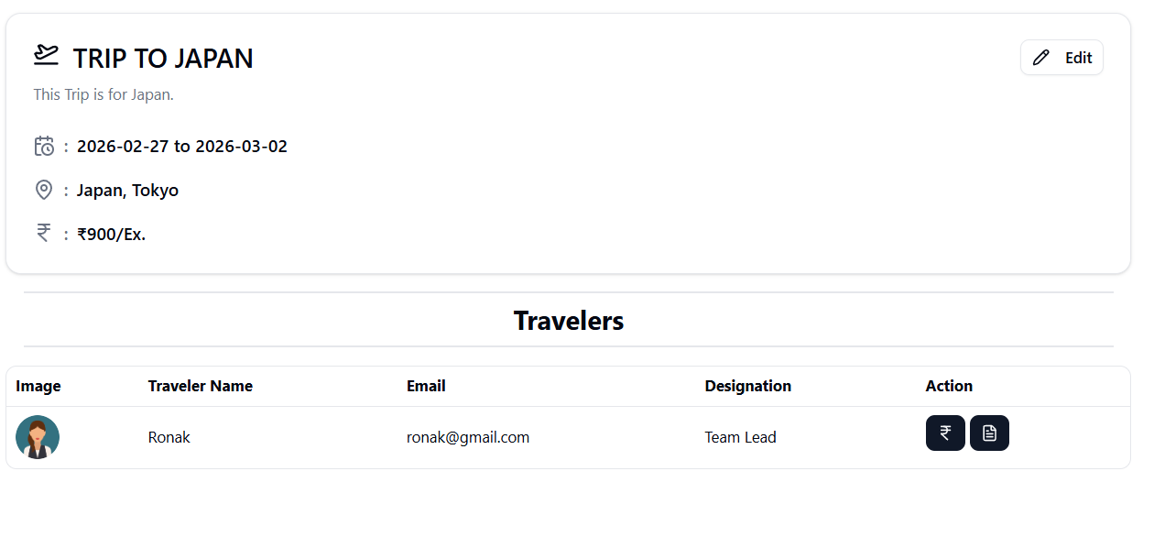
- Travel Create Page
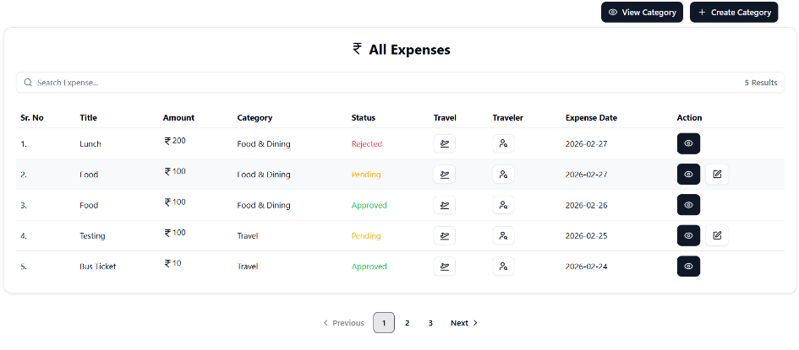
- Travel Detail Page with travellers
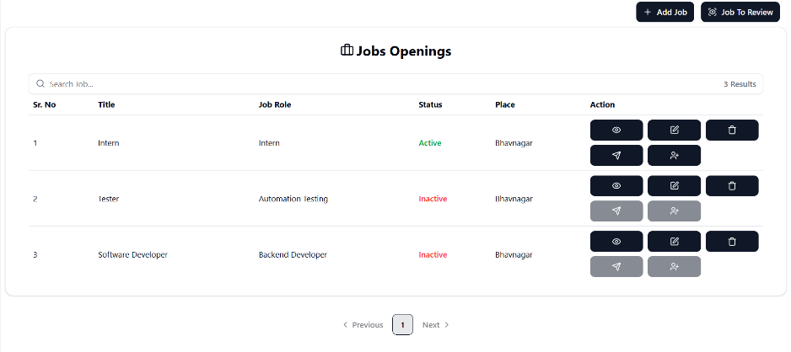
- All Travel Expenses of Traveller for changing status of it and preview proof of expense.
- Job Opening Created by logged in HR.
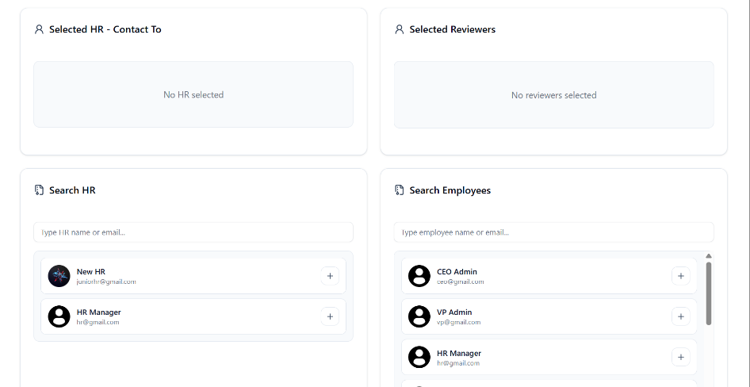
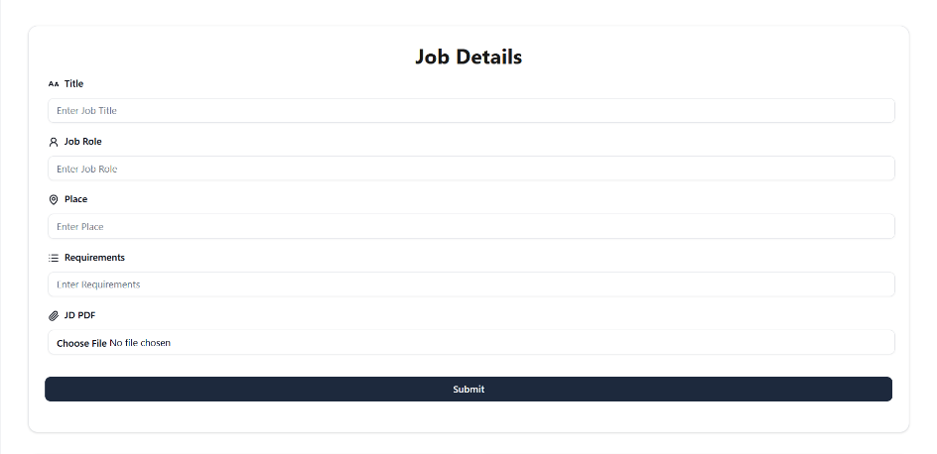
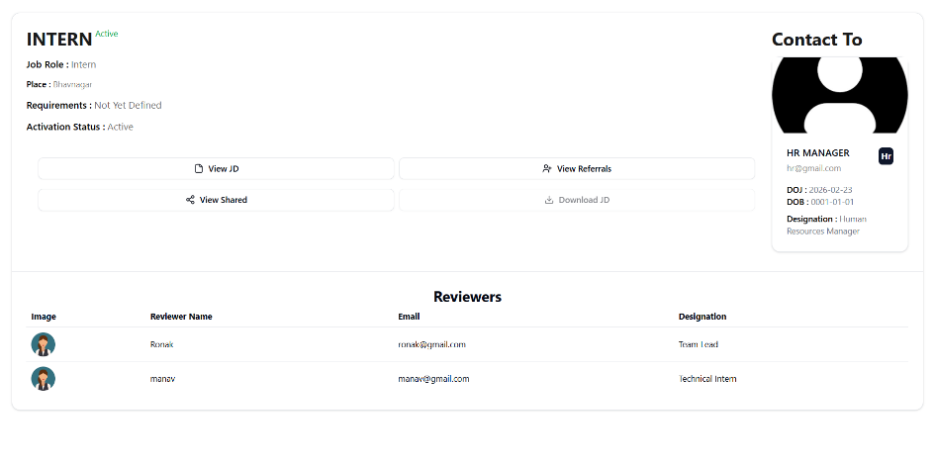
- Create Job For Opening.
- Job Detail with reviewers and Contact to Detail

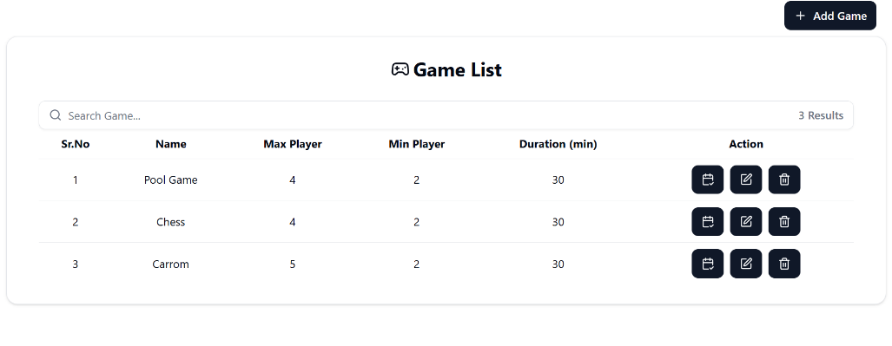
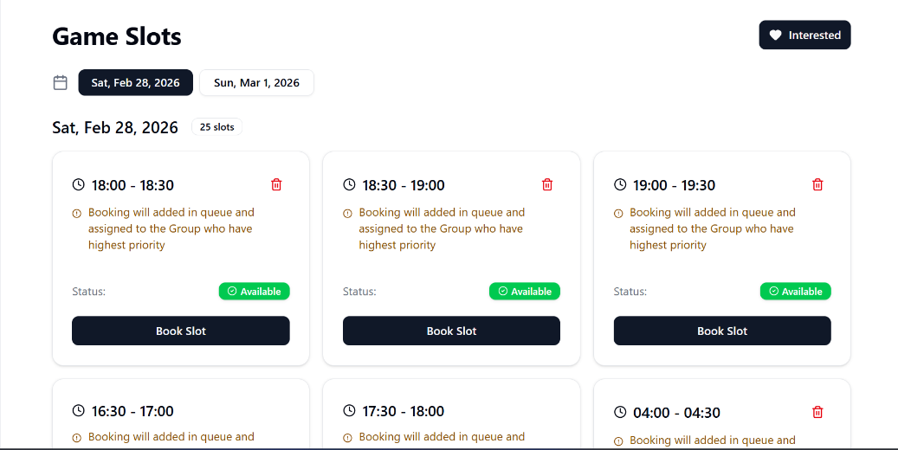
- All Game Of System.
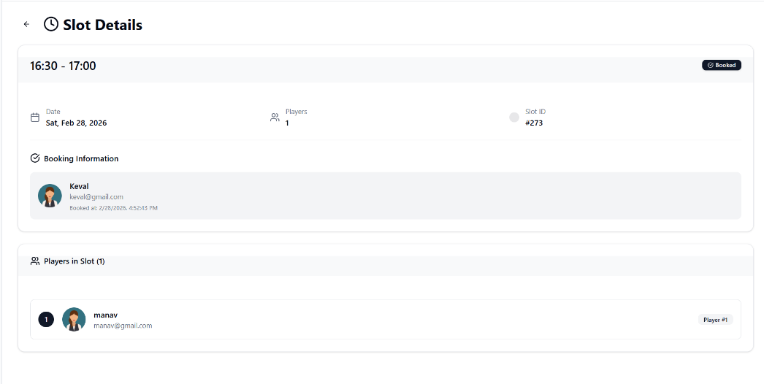
- Game Slot
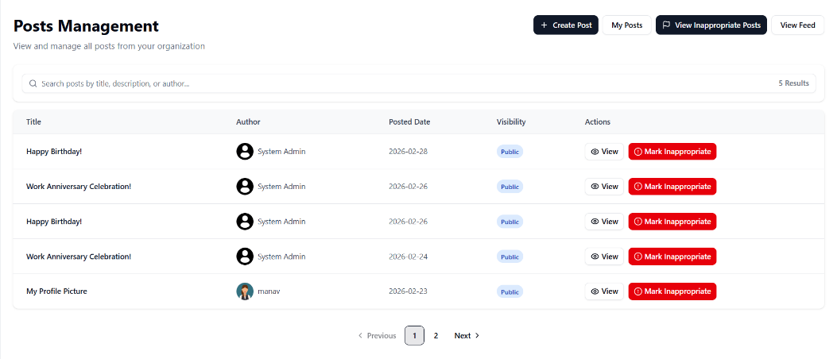
- Game Slot Booking Details with who booked and player of that slot.
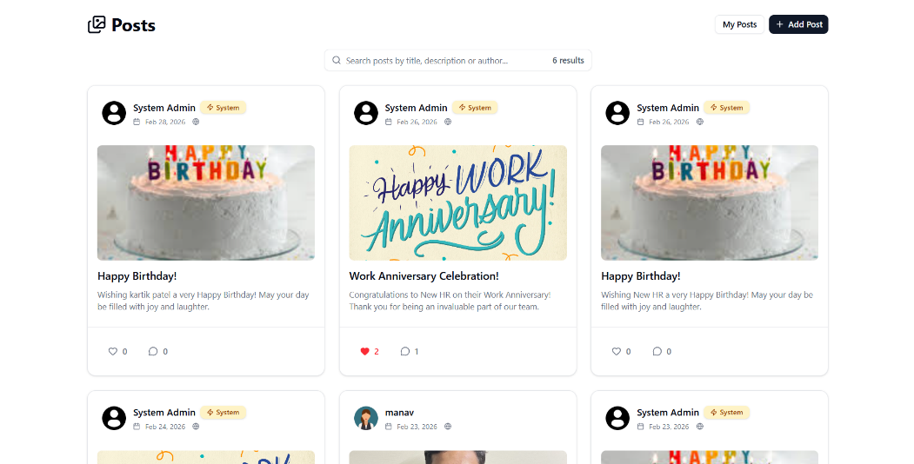
- Manage Post By HR to make post inappropriate or view details.
- Post Feed For All User who are logged in system

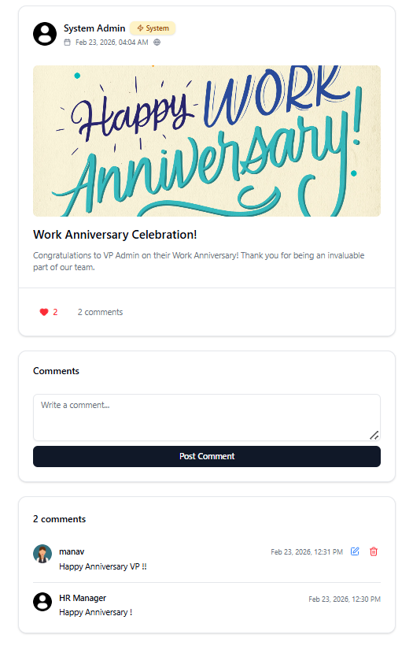

- Post Detail with Comment and like count.

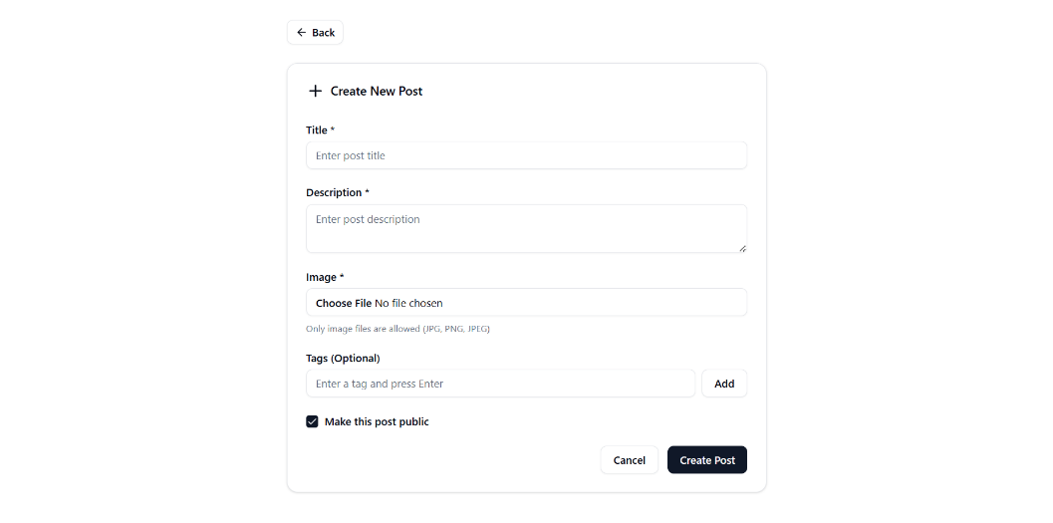
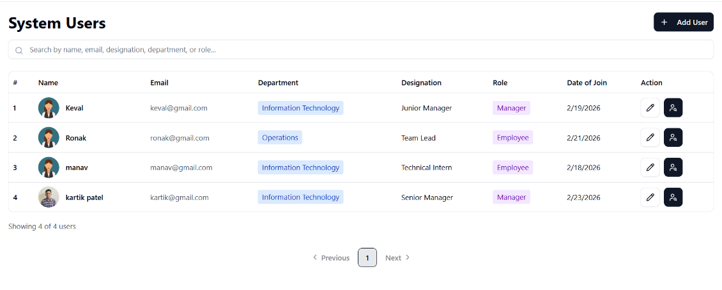
- Create Post Form.
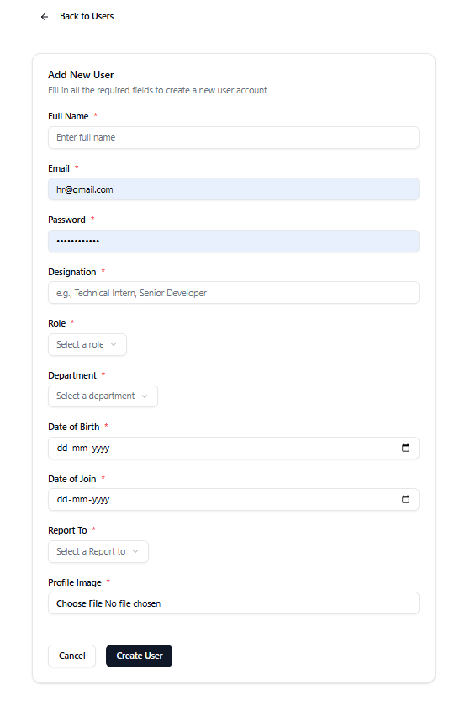
- Manage User Page for HR

- Create User Page.
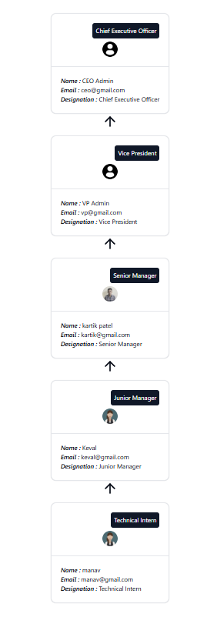
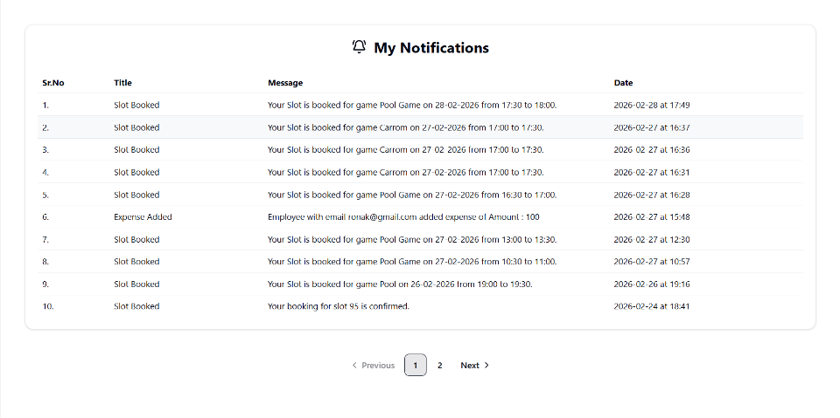
- Notification of current logged in user.
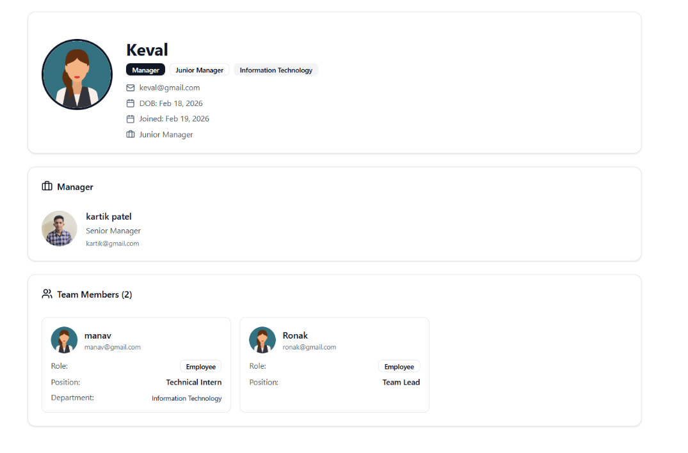
- Organization Chart
- User Profile with his Manager and His Team(if user is manager)
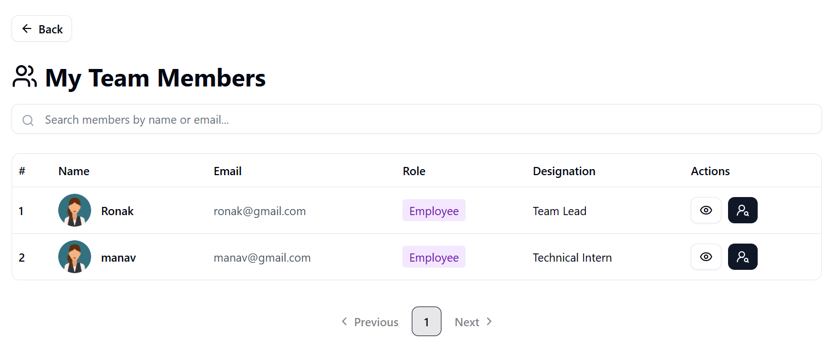
- My Team Detail for Manager
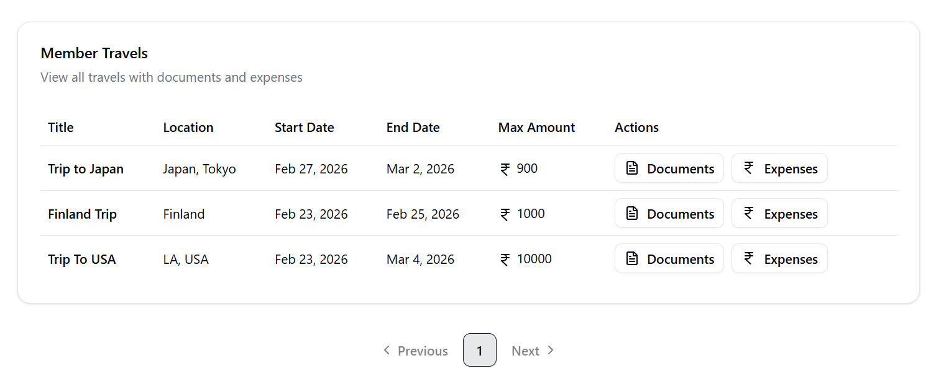

- Team Member Travel Detail
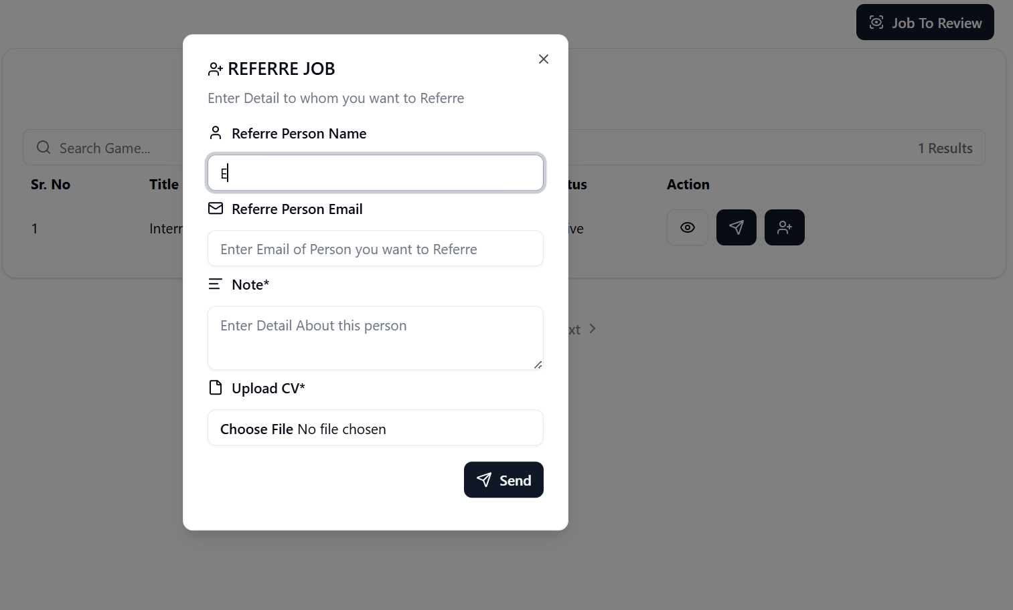

- Job Referral Create Form

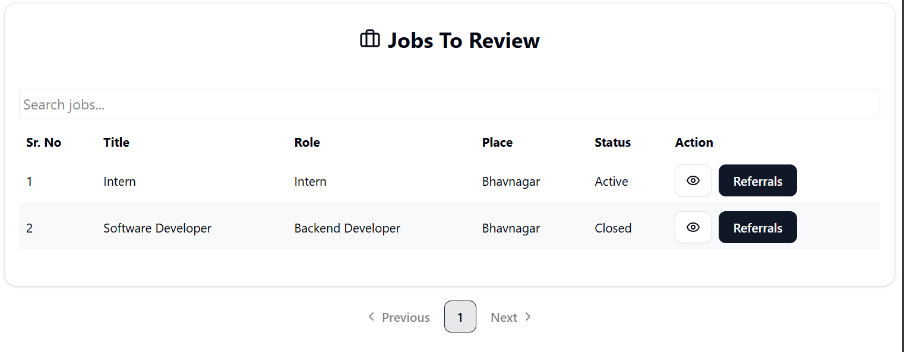

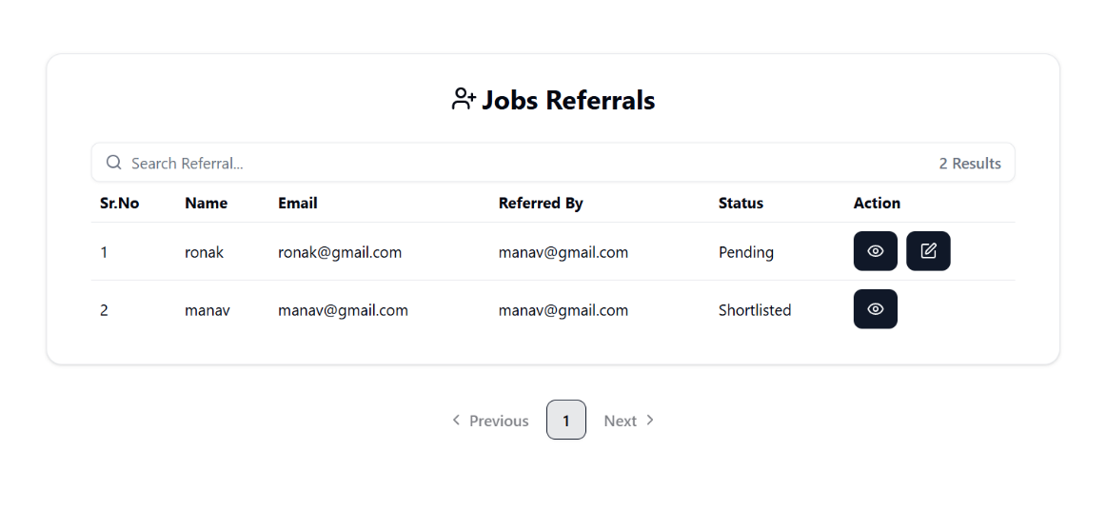
- Job To review Page for Job Reviewers

- Job Referrals for Review.

  - Reports :

8.3 Testing :
8.3.1 Testing Strategy :
- Black-Box Testing
Black box testing is a testing technique in which the internal workings of the software are not known to the tester. The tester only focuses on the input and output of the software. Black box testing is mainly focused on testing the functionality of the software, ensuring that it meets the requirements and specifications. Black box testing uses methods like equivalence partitioning, boundary value analysis, and error guessing to create test cases.

8.3.2 Test cases and results :
- Add Travel Form:
Test Case ID | Form/Screen | Field Name | Test Scenario | Input Data | Expected Result | Actual Result | Status (Pass / Fail)
1 | Add Travel Form | Travel Title | Valid Travel Title | Business Trip | Accepted | Accepted | Pass
2 | Add Travel Form | Travel Title | Empty Travel Title |  | Validation Error | Validation Error | Pass
3 | Add Travel Form | Travel Title | Title exceeds maximum length | 300 characters | Validation Error | Validation Error | Pass
4 | Add Travel Form | Travel Description | Valid Description | Client meeting in Delhi office | Accepted | Accepted | Pass
5 | Add Travel Form | Travel Description | Empty Description |  | Validation Error | Validation Error | Pass
6 | Add Travel Form | Travel Location | Valid Location | Delhi | Accepted | Accepted | Pass
7 | Add Travel Form | Travel Location | Empty Location |  | Validation Error | Validation Error | Pass
8 | Add Travel Form | Start Date | Valid Start Date | 10-06-2026 | Accepted | Accepted | Pass
9 | Add Travel Form | Start Date | Empty Start Date |  | Validation Error | Validation Error | Pass
10 | Add Travel Form | End Date | Valid End Date | 15-06-2026 | Accepted | Accepted | Pass
11 | Add Travel Form | End Date | End Date earlier than Start Date | Start: 15-06-2026 End: 10-06-2026 | Validation Error | Validation Error | Pass
12 | Add Travel Form | End Date | Empty End Date |  | Validation Error | Validation Error | Pass
13 | Add Travel Form | Max Amount Per Day | Valid Amount | 2000 | Accepted | Accepted | Pass
14 | Add Travel Form | Max Amount Per Day | Empty Amount |  | Validation Error | Validation Error | Pass
15 | Add Travel Form | Max Amount Per Day | Negative Amount | -500 | Validation Error | Validation Error | Pass
16 | Add Travel Form | Max Amount Per Day | Non-numeric input | abc | Validation Error | Validation Error | Pass
17 | Add Travel Form | Submit Button | Submit with valid data | Valid Form Data | Travel record created successfully | Travel record created successfully | Pass
18 | Add Travel Form | Cancel Button | Click cancel button | — | User redirected to travel list page | Redirect successful | Pass
- Job Opening Create Form:
Test Case ID | Form/Screen | Field Name | Test Scenario | Input Data | Expected Result | Actual Result | Status (Pass / Fail)
1 | Job Details Form | Title | Valid Job Title | Software Engineer | Accepted | Accepted | Pass
2 | Job Details Form | Title | Empty Job Title |  | Validation Error | Validation Error | Pass
3 | Job Details Form | Title | Very long title | 300 characters | Validation Error | Validation Error | Pass
4 | Job Details Form | Job Role | Valid Job Role | Backend Developer | Accepted | Accepted | Pass
5 | Job Details Form | Job Role | Empty Job Role |  | Validation Error | Validation Error | Pass
6 | Job Details Form | Place | Valid Place | Ahmedabad | Accepted | Accepted | Pass
7 | Job Details Form | Place | Empty Place |  | Validation Error | Validation Error | Pass
8 | Job Details Form | Requirements | Valid Requirements | Java, Spring Boot, SQL | Accepted | Accepted | Pass
9 | Job Details Form | Requirements | Empty Requirements |  | Validation Error | Validation Error | Pass
10 | Job Details Form | JD PDF | Upload valid PDF file | JD.pdf | Accepted | Accepted | Pass
11 | Job Details Form | JD PDF | Upload invalid file type | JD.png | Validation Error | Validation Error | Pass
12 | Job Details Form | JD PDF | No file uploaded |  | Validation Error | Validation Error | Pass
13 | HR Selection Panel | Search HR | Search HR by name | Komal Patel | HR appears in list | HR appears in list | Pass
14 | HR Selection Panel | Search HR | Search HR by email | hr@gmail.com | HR appears in list | HR appears in list | Pass
15 | HR Selection Panel | Select HR | Add HR using + button | Komal Patel | HR added to "Selected HR" section | HR added successfully | Pass
16 | HR Selection Panel | Select HR | Select multiple HR users | Komal Patel, Falguni Patel | Both HR users added | Added successfully | Pass
17 | HR Selection Panel | Select HR | No HR selected |  | Validation Error | Validation Error | Pass
18 | Reviewer Selection Panel | Search Employees | Search employee by name | CEO | Employee displayed in list | Employee displayed | Pass
19 | Reviewer Selection Panel | Search Employees | Search employee by email | vp@gmail.com | Employee displayed | Employee displayed | Pass
20 | Reviewer Selection Panel | Select Reviewer | Add reviewer using + button | VP | Reviewer added to selected list | Reviewer added | Pass
21 | Reviewer Selection Panel | Select Reviewer | Add multiple reviewers | VP, System Admin | Both reviewers added | Added successfully | Pass
22 | Reviewer Selection Panel | Select Reviewer | No reviewer selected |  | Validation Error | Validation Error | Pass
23 | Job Details Form | Submit Button | Submit with valid inputs | Valid job details | Job created successfully | Job created successfully | Pass
24 | Job Details Form | Submit Button | Submit with missing fields | Missing title | Validation error displayed | Validation error displayed | Pass

- Game Create Form:
Test Case ID | Form/Screen | Field Name | Test Scenario | Input Data | Expected Result | Actual Result | Status (Pass / Fail)
1 | Create New Game | Name | Valid Game Name | Chess | Accepted | Accepted | Pass
2 | Create New Game | Name | Empty Game Name |  | Validation Error | Validation Error | Pass
3 | Create New Game | Name | Game name too long | 300 characters | Validation Error | Validation Error | Pass
4 | Create New Game | Max Player | Valid Max Player | 4 | Accepted | Accepted | Pass
5 | Create New Game | Max Player | Empty Max Player |  | Validation Error | Validation Error | Pass
6 | Create New Game | Max Player | Negative value | -2 | Validation Error | Validation Error | Pass
7 | Create New Game | Max Player | Non-numeric value | abc | Validation Error | Validation Error | Pass
8 | Create New Game | Min Player | Valid Min Player | 2 | Accepted | Accepted | Pass
9 | Create New Game | Min Player | Empty Min Player |  | Validation Error | Validation Error | Pass
10 | Create New Game | Min Player | Min Player greater than Max Player | Min=5 Max=4 | Validation Error | Validation Error | Pass
11 | Create New Game | Duration (Minutes) | Valid Duration | 30 | Accepted | Accepted | Pass
12 | Create New Game | Duration (Minutes) | Empty Duration |  | Validation Error | Validation Error | Pass
13 | Create New Game | Duration (Minutes) | Negative Duration | -10 | Validation Error | Validation Error | Pass
14 | Create New Game | Slot Assigned (Min) | Valid Slot Assigned | 60 | Accepted | Accepted | Pass
15 | Create New Game | Slot Assigned (Min) | Empty Slot Assigned |  | Validation Error | Validation Error | Pass
16 | Create New Game | Slot Assigned (Min) | Non-numeric value | abc | Validation Error | Validation Error | Pass
17 | Create New Game | Slot Create For Next (Days) | Valid days value | 7 | Accepted | Accepted | Pass
18 | Create New Game | Slot Create For Next (Days) | Empty days value |  | Validation Error | Validation Error | Pass
19 | Create New Game | Slot Create For Next (Days) | Negative days value | -5 | Validation Error | Validation Error | Pass
20 | Create New Game | Create Slot Button | Submit valid game configuration | Valid form data | Game created and slots generated successfully | Game created successfully | Pass

- Post Create Form:
Test Case ID | Form/Screen | Field Name | Test Scenario | Input Data | Expected Result | Actual Result | Status (Pass / Fail)
1 | Create New Post | Title | Valid Title | Team Achievement | Accepted | Accepted | Pass
2 | Create New Post | Title | Empty Title |  | Validation Error | Validation Error | Pass
3 | Create New Post | Title | Very long title | 300 characters | Validation Error | Validation Error | Pass
4 | Create New Post | Description | Valid Description | Our team successfully completed the project | Accepted | Accepted | Pass
5 | Create New Post | Description | Empty Description |  | Validation Error | Validation Error | Pass
6 | Create New Post | Description | Very long description | 1000+ characters | Accepted | Accepted | Pass
7 | Create New Post | Image | Valid image upload | post.jpg | Accepted | Accepted | Pass
8 | Create New Post | Image | Upload PNG image | post.png | Accepted | Accepted | Pass
9 | Create New Post | Image | Upload invalid file type | post.pdf | Validation Error | Validation Error | Pass
10 | Create New Post | Image | No image uploaded |  | Validation Error | Validation Error | Pass
11 | Create New Post | Tags | Add valid tag | celebration | Tag added successfully | Tag added | Pass
12 | Create New Post | Tags | Add multiple tags | celebration, success | Tags added successfully | Tags added | Pass
13 | Create New Post | Tags | Empty tag input |  | Tag not added | Tag not added | Pass
14 | Create New Post | Public Checkbox | Checkbox checked | True | Post will be public | Post marked public | Pass
15 | Create New Post | Public Checkbox | Checkbox unchecked | False | Post will be private | Post marked private | Pass
16 | Create New Post | Create Post Button | Submit valid post | Valid form data | Post created successfully | Post created successfully | Pass
17 | Create New Post | Create Post Button | Submit with missing fields | Missing title | Validation error displayed | Validation error displayed | Pass
18 | Create New Post | Cancel Button | Click cancel button | — | Form closed without saving | Form closed | Pass

- User Create Form:
Test Case ID | Form/Screen | Field Name | Test Scenario | Input Data | Expected Result | Actual Result | Status (Pass / Fail)
1 | Add New User | Full Name | Valid full name | Kartik Patel | Accepted | Accepted | Pass
2 | Add New User | Full Name | Empty full name |  | Validation Error | Validation Error | Pass
3 | Add New User | Full Name | Name with numbers | Kartik123 | Validation Error | Validation Error | Pass
4 | Add New User | Email | Valid email | user@gmail.com | Accepted | Accepted | Pass
5 | Add New User | Email | Empty email |  | Validation Error | Validation Error | Pass
6 | Add New User | Email | Invalid email format | usergmail.com | Validation Error | Validation Error | Pass
7 | Add New User | Email | Existing email | hr@gmail.com | Server Side Error | Server Side Error | Pass
8 | Add New User | Password | Valid password | User@123 | Accepted | Accepted | Pass
9 | Add New User | Password | Empty password |  | Validation Error | Validation Error | Pass
10 | Add New User | Password | Weak password | 12345 | Validation Error | Validation Error | Pass
11 | Add New User | Designation | Valid designation | Software Engineer | Accepted | Accepted | Pass
12 | Add New User | Designation | Empty designation |  | Validation Error | Validation Error | Pass
13 | Add New User | Role | Select valid role | Employee | Accepted | Accepted | Pass
14 | Add New User | Role | No role selected |  | Validation Error | Validation Error | Pass
15 | Add New User | Department | Select valid department | IT | Accepted | Accepted | Pass
16 | Add New User | Department | No department selected |  | Validation Error | Validation Error | Pass
17 | Add New User | Date of Birth | Valid date | 10-05-2000 | Accepted | Accepted | Pass
18 | Add New User | Date of Birth | Empty DOB |  | Validation Error | Validation Error | Pass
19 | Add New User | Date of Join | Valid joining date | 01-07-2024 | Accepted | Accepted | Pass
20 | Add New User | Date of Join | Joining date before DOB | DOB: 10-05-2000 Join: 01-01-1995 | Validation Error | Validation Error | Pass
21 | Add New User | Report To | Select manager | VP | Accepted | Accepted | Pass
22 | Add New User | Profile Image | Upload valid image | profile.jpg | Accepted | Accepted | Pass
23 | Add New User | Profile Image | Upload invalid file | profile.pdf | Validation Error | Validation Error | Pass
24 | Add New User | Profile Image | No image uploaded |  | Validation Error | Validation Error | Pass
25 | Add New User | Create User Button | Submit valid form | Valid form data | User created successfully | User created successfully | Pass
26 | Add New User | Cancel Button | Click cancel button | — | Form closes without saving | Form closed | Pass

- Expense Create Form:
Test Case ID | Form/Screen | Field Name | Test Scenario | Input Data | Expected Result | Actual Result | Status (Pass / Fail)
1 | Add New Expense | Details | Valid expense details | Taxi fare to airport | Accepted | Accepted | Pass
2 | Add New Expense | Details | Empty expense details |  | Validation Error | Validation Error | Pass
3 | Add New Expense | Details | Very long description | 500+ characters | Accepted | Accepted | Pass
4 | Add New Expense | Amount | Valid amount | 1500 | Accepted | Accepted | Pass
5 | Add New Expense | Amount | Empty amount |  | Validation Error | Validation Error | Pass
6 | Add New Expense | Amount | Negative amount | -100 | Validation Error | Validation Error | Pass
7 | Add New Expense | Amount | Non-numeric amount | abc | Validation Error | Validation Error | Pass
8 | Add New Expense | Expense Date | Valid expense date | 10-06-2026 | Accepted | Accepted | Pass
9 | Add New Expense | Expense Date | Empty expense date |  | Validation Error | Validation Error | Pass
10 | Add New Expense | Expense Date | Date outside travel period | 01-01-2030 | Validation Error | Validation Error | Pass
11 | Add New Expense | Category | Valid category selected | Travel | Accepted | Accepted | Pass
12 | Add New Expense | Category | No category selected |  | Validation Error | Validation Error | Pass
13 | Add New Expense | Proof | Upload valid PDF receipt | receipt.pdf | Accepted | Accepted | Pass
14 | Add New Expense | Proof | Upload valid image receipt | receipt.jpg | Accepted | Accepted | Pass
15 | Add New Expense | Proof | Upload unsupported file type | receipt.exe | Validation Error | Validation Error | Pass
16 | Add New Expense | Proof | No file uploaded |  | Validation Error | Validation Error | Pass
17 | Add New Expense | Submit Button | Submit with valid form data | Valid expense data | Expense submitted successfully | Expense submitted successfully | Pass
18 | Add New Expense | Submit Button | Submit with missing required fields | Missing amount | Validation error displayed | Validation error displayed | Pass
- Travel Document Add Form:
Test Case ID | Form/Screen | Field Name | Test Scenario | Input Data | Expected Result | Actual Result | Status (Pass / Fail)
1 | Add Travel Document | Document Name | Valid document name | Flight Ticket | Accepted | Accepted | Pass
2 | Add Travel Document | Document Name | Empty document name |  | Validation Error | Validation Error | Pass
3 | Add Travel Document | Document Name | Very long document name | 300 characters | Validation Error | Validation Error | Pass
4 | Add Travel Document | Document Type | Valid document type | Ticket | Accepted | Accepted | Pass
5 | Add Travel Document | Document Type | Empty document type |  | Validation Error | Validation Error | Pass
6 | Add Travel Document | Document Type | Invalid characters in document type | @@@ | Validation Error | Validation Error | Pass
7 | Add Travel Document | Document File | Upload valid PDF file | ticket.pdf | Accepted | Accepted | Pass
8 | Add Travel Document | Document File | Upload image file | ticket.jpg | Accepted | Accepted | Pass
9 | Add Travel Document | Document File | Upload unsupported file type | ticket.exe | Validation Error | Validation Error | Pass
10 | Add Travel Document | Document File | No file uploaded |  | Validation Error | Validation Error | Pass
11 | Add Travel Document | Upload Document Button | Submit valid document details | Valid document data | Document uploaded successfully | Document uploaded successfully | Pass
12 | Add Travel Document | Upload Document Button | Submit with missing required fields | Missing document name | Validation error displayed | Validation error displayed | Pass
13 | Add Travel Document | Cancel Button | Click cancel button | — | Modal closed without saving | Modal closed | Pass

- . FUTURE ENHANCEMENT

- Mobile Application Support
- Multi-Level Approval Workflow
- AI-Based Resume Screening
- Real-Time Notifications System

- . BIBLIOGRAPHY

